**DAILY ONLINE ACTIVITIES SUMMARY**

|  |  |  |  |  |  |  |  |  |
| --- | --- | --- | --- | --- | --- | --- | --- | --- |
| **Date:** | **03/06/2020** | | | | | **Name:** | **Lavanya D M** | |
| **Sem & Sec** | **4th & ‘A’** | | | | | **USN:** | **4al18cs041** | |
| **Online Test Summary** | | | | | | | | |
| **Subject** | | **OOC** | | | | | | |
| **Max. Marks** | | **30** | | **Score** | | | **12** | |
| **Certification Course Summary** | | | | | | | | |
| **Course** | **Building WordPress website without coding** | | | | | | | |
| **Certificate Provider** | | | **Bidegree** | | **Duration** | | | **3DAYS,3hrs** |
| **Coding Challenges** | | | | | | | | |
| **Problem Statement:1)** Write a code segment in java to swap two numbers using call by object reference.  2) Write a Java program to find Last Digit of a^b (a to the power b) for Large Numbers  3) Write a function that takes a two-digit number and determines if it's the largest of two possible digit swaps | | | | | | | | |
| **Status: complied** | | | | | | | | |
| **Uploaded the report in GitHub** | | | | | **yes** | | | |
| **If yes Repository name** | | | | | <https://github.com/lavanyamurthi/lockdown-coding/tree/master> | | | |
| **Uploaded the report in slack** | | | | | **yes** | | | |

Online Test Details: (Attach the snapshot and briefly write the report for the same)

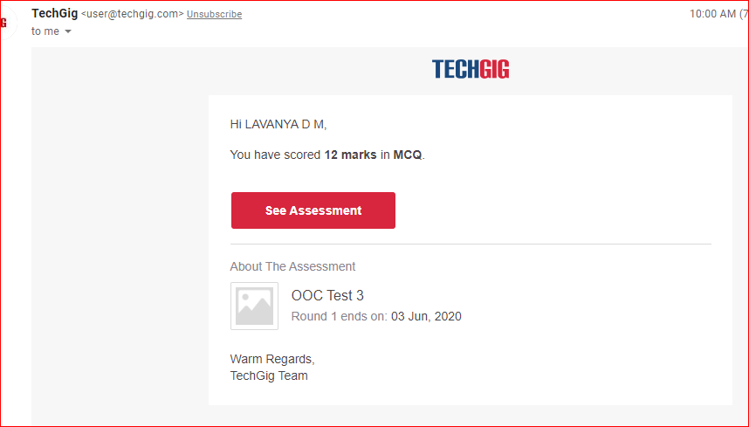

Certification Course Details: (Attach the snapshot and briefly write the report for the same)

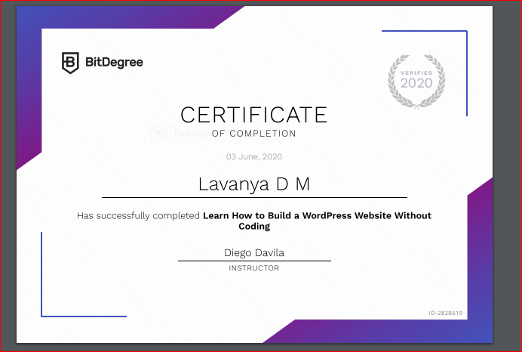

I had completed the course successfully and this is the certificate issued GitHub link is

<https://github.com/lavanyamurthi/lockdown-certificate>

Coding Challenges Details: (Attach the snapshot and briefly write the report for the same)

Problem 1: Write a code segment in java to swap two numbers using call by object reference.

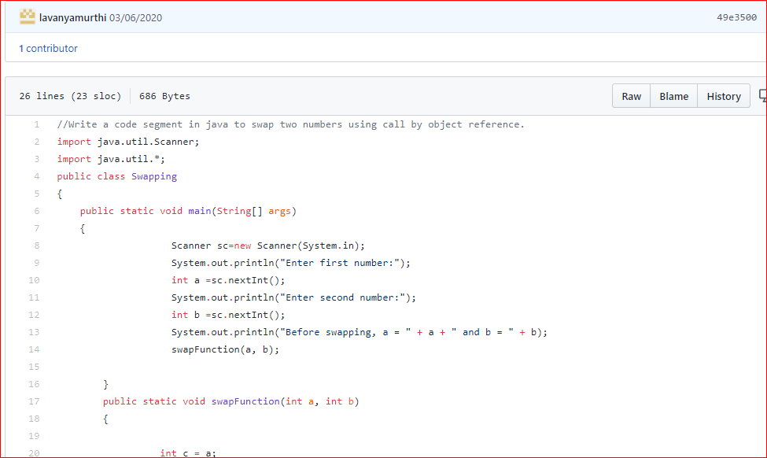

**Problem 2:**Write a Java program to find Last Digit of a^b (a to the power b) for Large Numbers

You are given two integer numbers, the base a (number of digits d, such that 1 <= d <= 1000) and the index b (0 <= b <= 922*10^15). You have to find the last digit of a^b.

Examples:

Input : 3 10  
Output : 9

Input : 6 2  
Output : 6

Algorithm  
Algorithm :

1. Since number are very large we store them as a string.
2. Take last digit in base a.
3. Now calculate b%4. Here b is very large.  
   -> If b%4==0 that means b is completely divisible by 4, so our exponent now will be exp = 4  
   because by multiplying number 4 times, we get the last digit according to cycle table in  
   above diagram.  
   ->If b%4!=0 that means b is not completely divisible by 4, so our exponent now will be  
   exp=b%4 because by multiplying number exponent times, we get the last digit according to  
   cycle table in above diagram.  
   -> Now calculate digit = pow( last_digit_in_base, exp ).  
   ->Last digit of a^b will be ldigit%10.

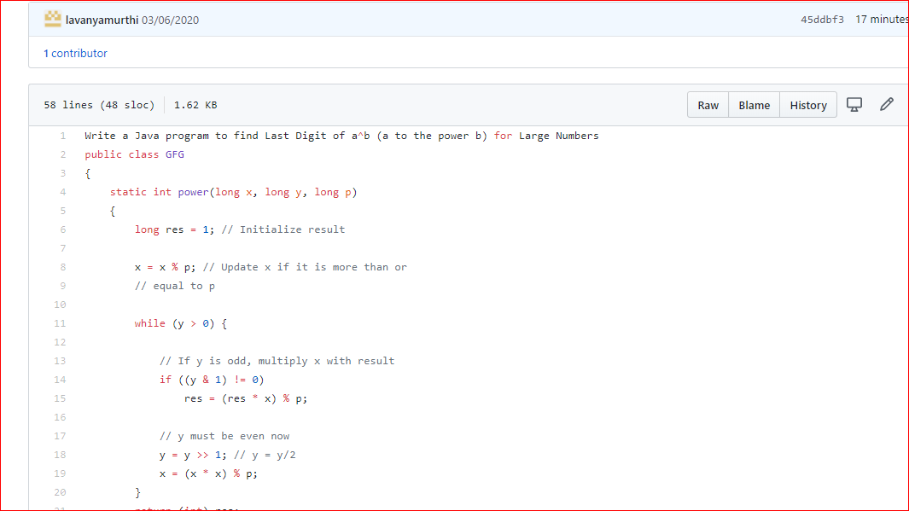

Problem 3: Write a function that takes a two-digit number and determines if it's the largest of two possible digit swaps

To illustrate: largestSwap(27) ➞ false largestSwap(43) ➞ true If 27 is our input, we should return false because swapping the digits gives us 72, and 72 > 27. On the other hand, swapping 43 gives us 34, and 43 > 34. Examples largestSwap(14) ➞ false largestSwap(53) ➞ true largestSwap(99) ➞ true

